Feedback Form

Share your worries, concerns or compliments! Help us to get it right!


This form is for you to give us feedback on something that you are happy about or something that you an unhappy about

You do not need to give your name but if you do, we can tell you what we are doing to put it right or thank you for your compliment.
If you are telling us about something on behalf of another person, it would be helpful to know their name and address too, if they consent to this.

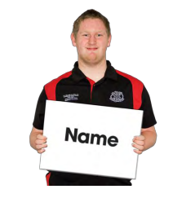
Your name:

The name or address of the person you are writing on behalf of:


Your complaint or compliment will be kept confidential unless you say it’s okay to share this information.
This means that we will help you with your complaint but we won’t tell anyone that it was you who sent it.

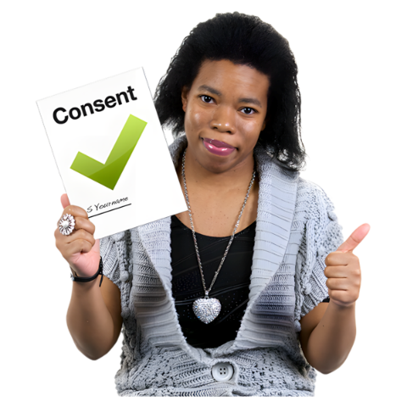
If you are happy for us to share your complaint or compliment with your name, please tick this box. If not, leave it empty.

Yes you can share my name



If you share information that might be a safeguarding or something about a crime, we will need to report this. We may need to share your information with someone, including your name. We will let you know who we will share your information with.


What would you like to share with us? Tick the relevant box



Something you are
happy with
Something you are
unhappy with

Tell us about it:


Is there anything you would like us to do to help?



How can we get in touch with you if you want a reply?

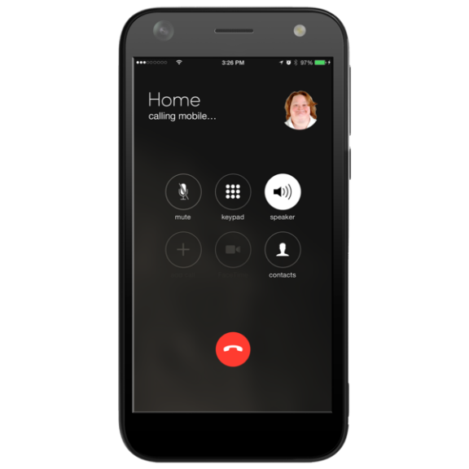

      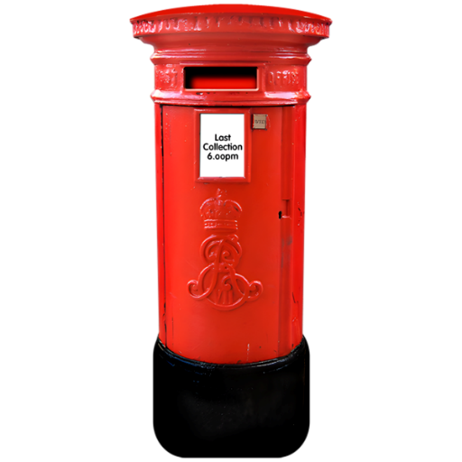 | Thank you for filling in our feedback form.  Please send this form to speakup@milewood.co.uk  Or post it to  Feedback  Milewood  4 Sidings Court,  Doncaster DN4 5NU  We will tell you when we have received your form and let you know what we are going to do next

